# **Game Design Document**

# ***LepreSeán***

# **Table of Contents**

### 

**Introduction** **3**

Story Overview 3

“A trip to the Stables - with a twist!” 3

**Game Mechanics** **4**

General 4

Controls/Player Interaction 5

Puzzles 6

**Game Elements** **7**

Characters 7

**Game Progression** **8**

General 8

Level One 8

Level Two 8

Level Three 9

Level Four 9

**System Menus/Cutscenes** **10**

**Graphics Overview** 11

Assets 11

Character List 11

Environment Art List 11

Items 11

**Audio Overview** **12**

## **Introduction**

LepreSeán is an innovative game that combines the best aspects of the biggest names in the games industry to date. We elected to attempt this medley in an effort to create a familiar environment, with a twist that we believe sets us apart from other groups. Having little to no experience with graphics, we focused on making a diverse game mechanically, each level containing different physics and characters.

Given the nature of the game, there are no central features to speak of, as each level has its own unique features and progression. While you start off as LepreSeán, featuring speed and invisibility, in level 2, you take the form of a bird that can fly to overcome any potential issues. Following that, you change into a dog which possesses a keen sense of smell in level 3. This leads you to level 4, in which you morph into a mouse, which, due to its small size, goes unnoticed in Stables.

### **Story Overview**

#### **“A trip to the Stables - with a twist!”**

The game follows a young, intrepid LepreSeán on a quest to fulfil his destiny of reaching the end of the rainbow. You must accompany him on this quest to ensure his safe passage through the perilous grounds of UL. On the journey, you will undoubtedly meet both friend and foe. Be careful though, because you can’t live forever. The unknowing LepreSeán only has three lives per level, so the player must be sure not to waste them. The game works up, level by level, to the final challenge which you will attempt in mouse form.

Each level presents a new challenge, constantly giving the player a new experience of the game. We really feel that this game will appeal to UL students as well as appealing to anyone that is familiar with the gamemode styles we’ve implemented, such as platformer and sidescroller.



## **Game Mechanics**

### **General**

* We used the Corona platform to build this game, and it is written in the Lua programming language.
* It is designed for Windows PCs, but could be implemented on other devices.
* The game is a sidescroller, which involved using code to move the backgrounds off screen and then translate them back to the other side once they reached a certain point off screen.
* We used several layers of backgrounds, moving at different speeds, in order to increase the realistic feel of the background actually moving.
* There are only three essential controls - forward, backwards and jump buttons - in the first and fourth levels.
* The player can move left or right, though they are bounded by the screen, and they can jump also.
* If they try to move offscreen, the player loses a life and he is moved back to the start position on the left of the screen.
* In the second level, the player moves by tapping. They must continuously tap to get through the level and avoid obstacles.
* In the third level, the player must navigate a maze and find an object to complete the level. The maze was implemented by using multiple images and layering them over each other, and has special collision boundaries in which the player must avoid the wrong coloured areas.
* The player can collect gold coins along the way and these will increase the player’s score. They pick up the coins simply by colliding with them.
* We used the physics engine to do various things. There are multiple collisions occurring in the game, mostly between dynamic (LepreSeán) and static (eg. obstacles) objects, and so we had to ensure these would be detected and the correct action would be taken depending on whether the collision was with an obstacle that would improve the player’s score or take a life.
* The Composer library in Lua was used in order to implement the various levels, as well as to display the game over screen and allow the player to restart when they die in game.

### **Controls/Player Interaction**

* The player uses the W,A,S,D or arrow keys to move LepreSeán in the first, third and fourth levels. We decided to implement both options as different people have different preferences.
* In the first and fourth levels the player can also use the spacebar to jump onto platforms and to avoid obstacles.
* The game utilises mouse clicks in the second level as well as for selecting options, and restarting.



### **Puzzles**

* This game will feature a maze without borders in level 3. The player must navigate an open space following colours which represent scents for the character.
* The player will be penalised if they stray off the path, while the game will be actively trying to pull them from the path.
* If the player strays into red zones, which represent the scents of other objects, they will be forced to go back to the start and get the scent of the cane from the blind man again.
* Green zones are places where the player will be penalised by having time go quicker there but they will not lose the scent of the cane.

## **Game Elements**

### **Characters**

* The main character of our game is LepreSeán, who is a magical shape-shifting leprechaun. He has the ability to transform into multiple different animals, 3 of which the player will see in game.
* LepreSeán is an Irish lad, who only wants to find the gold at the end of the rainbow, which has been his dream for as long as he can remember. However, he can’t do it alone - he needs the player’s help to make it past all the university students and faculty members and find his gold.
* The blind man is a character who LepreSeán will meet in level 3, and he requires assistance in finding his cane.
* The Rainbow Man is a mysterious figure who will feature throughout the game, offering sage advice and guiding the player in their quest to fulfill LepreSeán’s destiny.

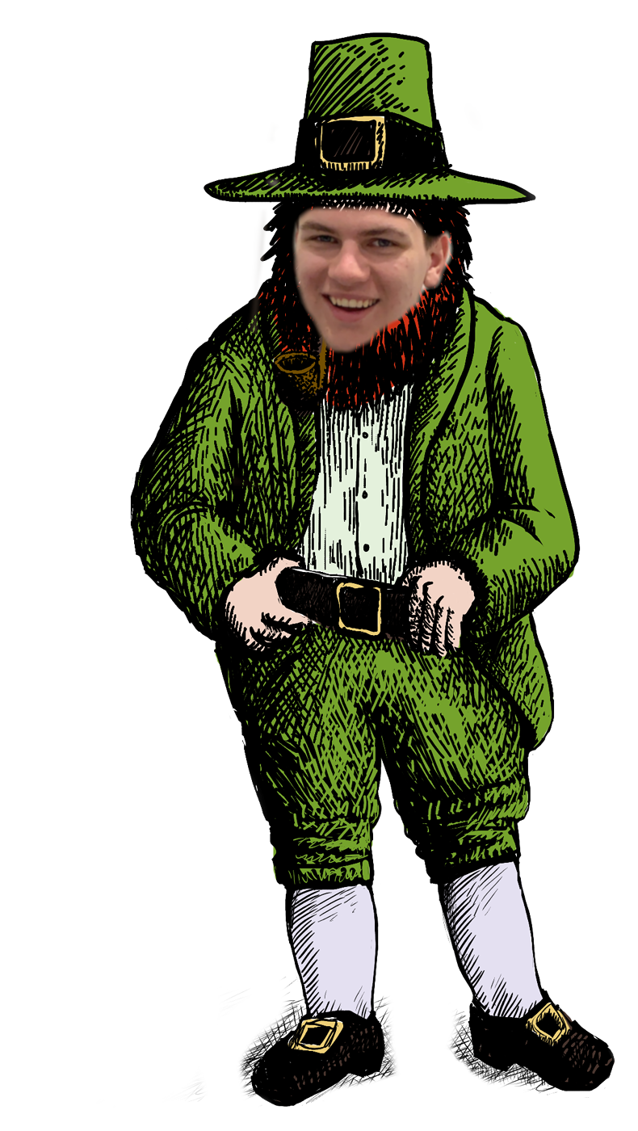

## **Game Progression**

### **General**

* There are timers, lives, and scores in this game.
* The player will progress to the next level if they achieve a certain score by collecting enough gold coins in Levels 1 and 2.
* They must also successfully play through the level without losing all their lives, or running out of time in level three.
* The game will feature 4 unique levels, and the player must run, jump, fly, and figure out a maze puzzle throughout.
* There are multiple obstacles that the player must avoid in order to get through the levels, and the player can collect gold coins along the way which will boost their score.

### **Level One**

* Level one involves LepreSeán getting from the flagpoles to the first roundabout. He activates his invisibility, so no humans will see him.
* He must then avoid humans who are walking out of UL, by jumping over them. If he bumps into anybody, he will lose a life.
* At the end of the level, LepreSeán is at the roundabout and his food level is quite low. He decides to use the last of it to transform into a bird and find food in the trees off to the left.

### **Level Two**

* In level two, LepreSeán is now flying through the trees towards the drop off point outside the library.
* The player must keep him flying, while also avoiding obstacles, such as arrows, which appear due to the “Annual Archery Quiverfest” being on at the same time.
* The player must fly over the trees, while dodging the airborne projectiles. If the player touches the ground they will lose a life.
* At the end of the level, LepreSeán is outside the library and he sees a blind man in distress. He decides to help him find his cane, and shapeshifts into a dog.

### **Level Three**

* In level three, LepreSeán is a dog following scents (represented by colours on a top down map) to find the blind man’s cane. Explained further in Puzzles.
* The player must follow a specific scent in order to find the cane. There is a timer in this level also.

* The player will be slowly dragged off the path into parts of the park with other smells that will make the player lose their way and be penalised for time.
* At the end of the level, LepreSeán leaves the blind man at the entrance to the Stables, and shapeshifts into a mouse in order to enter undetected.

### **Level Four**

* In level four, the player is finally coming close to finding the gold.
* The rainbow leads the player to the “Holy Temple of Worship” known as the Stable’s Club and they must search inside for the gold.
* The player has to climb up from the back of the bar, using ladders, to where the rainbow ends. However, cans will be rolling towards them to prevent them from reaching their goal. They must fight their way from the floor to the top of the bar, in mouse form.
* This is the epic conclusion of the game, if the player succeeds they will receive the much coveted gold.
* In a shocking twist, LepreSeán discovers that this gold is in fact a can of Dutch Gold!

## **System Menus/Cutscenes**

* The main menu of the game has two options - “Play” and “Quit”. If the player chooses to play, the game will begin with a cutscene introducing the story to them.
* In game, player’s have the ability to pause the game, which was implemented using the Composer library’s overlay option. This keeps the game from continuing in the background while the pause menu is up, allowing the player to choose whether to continue the game or quit.
* There is a cutscene before each level, which basically function as informative menus, and feature the wise Rainbow man explaining the goal to LepreSeán.
* The first cutscene has two options: “Continue” and “Back to Menu” while the cutscenes for every other level just have a continue button. However, the player can also quit from ingame if they wish.
* The player also has the ability to choose which level they want to play, which will bring them to the cutscene just before the level.
* The Game Over and “You Won” screen offer two options also: “Play Again”, which brings the player back to the first cutscene, or “Quit”, which quits the application.

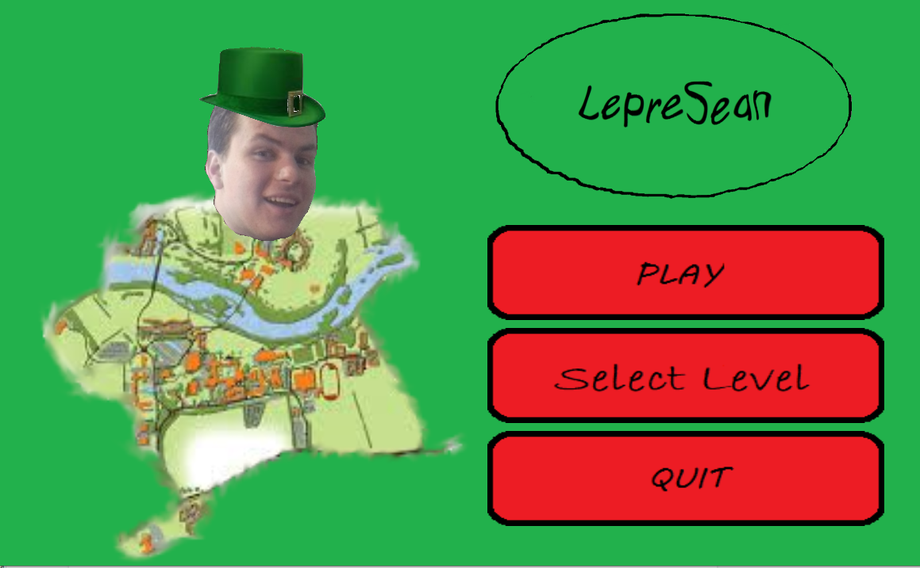

## **Graphics Overview**

* All of the graphics in the game were created by us, using pictures that we took of various locations around University of Limerick, or created using Paint.
* We used a combination of Paint, Krita and GIMP to create and manipulate these images, as well as the sprites, obstacles, and cutscenes in the game.
* All characters in the game have been created by us.
* We decided to use a red-green colour scheme, choosing green as the main character is a Leprechaun, and therefore Irish, and red as it contrasted nicely.
* We wanted to choose colours that would complement the lighthearted nature of the game, and thus the colour scheme involves only bright, vibrant colours.

### **Assets**

##### **Character List**

* + LepreSeán
  + Blue Bird
  + Purple Bird
  + Animated Dog
  + Standing Dog
  + Mouse
  + Rainbow Man

##### **Environment Art List**

* + Trees (Level 2 background)
  + Colored scents (Level 3 background)
  + Stables Bar (Level 4 background)
  + Crowds (Level 1)
  + Arrows (Level 2)
  + Walkway into UL (level 2 background)
  + Platforms (moving + non-moving)
  + Rolling cans + ladders (level 4)

##### **Items**

* + Coins

## **Audio Overview**

* The SFX in our game was obtained online, from free websites such as freesound.org
* We used Audacity to edit the sounds for jumping, losing a life, increasing score, and game over.
* Lots of websites that offer royalty free music and sound bites, we explored these to obtain .wav files and then edited them to suit our needs.
* The overall tone of the audio in LepreSeán is upbeat and light, fitting with the comedic theme of the game.
* The background music was implemented using audio.loadStream(), a function of the Corona audio library.
* We used a “kaching” sound for whenever the player picked up a gold coin.
* If the players reaches a game over screen, ominous music plays, while losing a life cause some darker music to be played also.